**Blood Donation Website**

### END TERM REPORT

*by*

**Sarthak Agarwal(**Roll no. RK17GAB37**),**

**Vaibhav Srivastava(**Roll no. RK17GAB49**),**

**Bhumika Agarwal (**Roll no. RK17GAB56**), Karishma Bhatnagar (**Roll no. RK17GAA32**)**



## Department of Intelligent Systems School of Computer Science Engineering Lovely Professional University, Jalandhar

### March-2018

**Student Declaration**

This is to declare that this report has been written by me/us. No part of the report is copied from other sources. All information included from other sources have been duly acknowledged. I/We aver that if any part of the report is found to be copied, I/we are shall take full responsibility for it.

Signature Sarthak Agarwal

Roll No. RK17GAB37

Signature Vaibhav Srivastava

Roll No. RK17GAB49

Signature Bhumika Agarwal

Roll No. RK17GAB56

Signature Karishma Bhatnagar

Roll No. RK17GAA32

**Place - Date –**

**TABLE OF CONTENTS**

**TITLE PAGE NO**

1. Background and objectives of project assigned 5

1.1 Goals… 6

1. Description of Project 7
2. Description of Work Division 8
3. Implementation of scheduled work of Project 8
   1. Homepage 8
   2. Products categories 9
   3. Registration 10
   4. Login page 10
   5. Product buying page 11
   6. Shopping Cart 11
4. Technologies and Framework to be used… 12
5. SWOT Analysis achieved in project 13
6. Conclusion 17

**BONAFIDE CERTIFICATE**

Certified that this project report “**Blood Donation Website**”

is the bonafide work of “Sarthak Agarwal, Vaibhav Srivastava, Bhumika Agarwal, Karishma Bhatnagar” who carried out the project work under my supervision.

Signature of the Supervisor Name of supervisor

Academic Designation

ID of Supervisor

Department of Supervisor

# 1. Background and objectives of project assigned

This Project “**BLOOD DONATION MANAGEMENT SYSTEM**”, assigned to us by **Dr. Nazir Ahmad** sir, is based on management of database of Blood Bank. Enabling the user to find the donors OR the blood packets of a particular Blood Group in the required location.

Where it deals with keeping the record of the donors their contact numbers and addresses and the availability of blood packets at the blood banks, also with the latest updates of organizations of Blood Donation Camps and Universities, and other public areas.

This project involves various concepts of CSS like Internal, External, Inline along with HTML 5.0 codes and JavaScript at the end to design a whole new fresh, responsive and active website.

* Returning to different parts of the site after registering as a donor or signing in.
* Easy availability of blood all over the nation.
* Effective categorical organization of blood groups.
* Simple navigation from home page to information and search links for specific blood group.
* Obvious information links or buttons.
* Consistent layout of information panel.

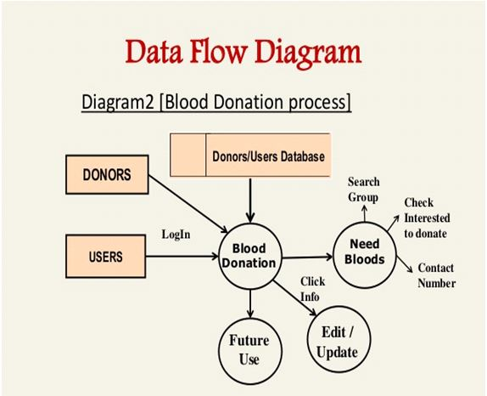

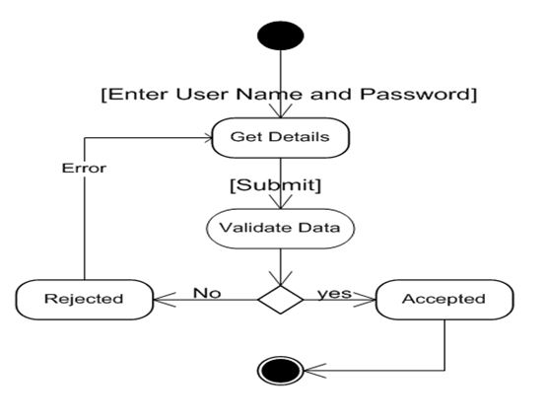

1. **Description of Work Division in terms of Roles among Students**

We worked as a team and did our best in completing the project. Every team member did a part of every work which was assigned to us. It’s hard to explain as we did a chunk of everything, which includes web designing, creating pages for products, linking different set of webpages to homepage, scraping pictures and product data from the sites, aligning the buttons and images, and making report.

# Implementation of scheduled work of Project

Here we will discuss about different parts of the website and how they will function.

* 1. **Homepage -**

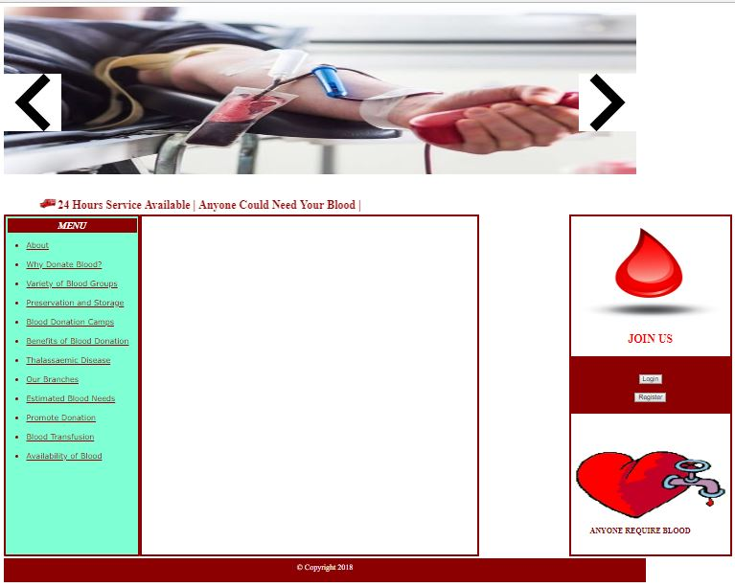

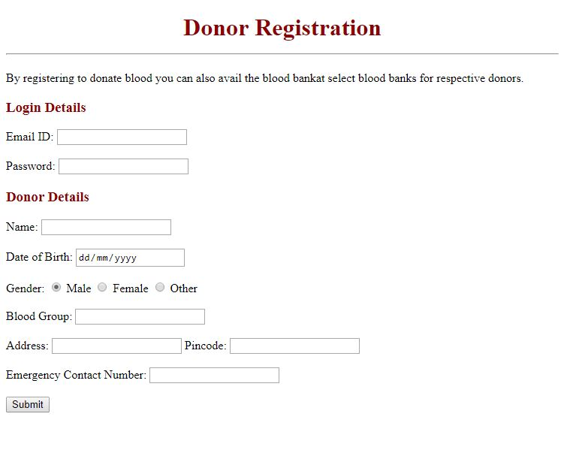

**4.4 Login page –** registered customers can login from here

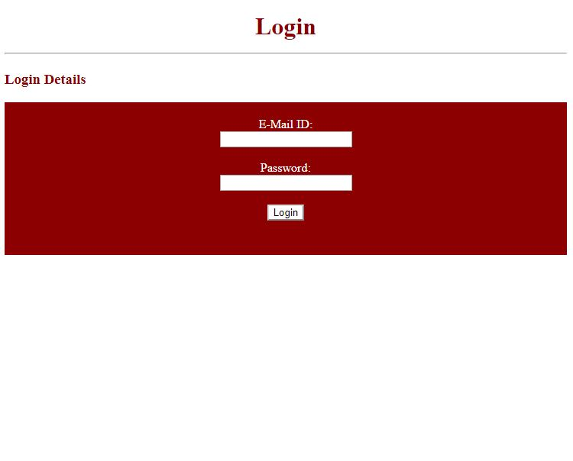

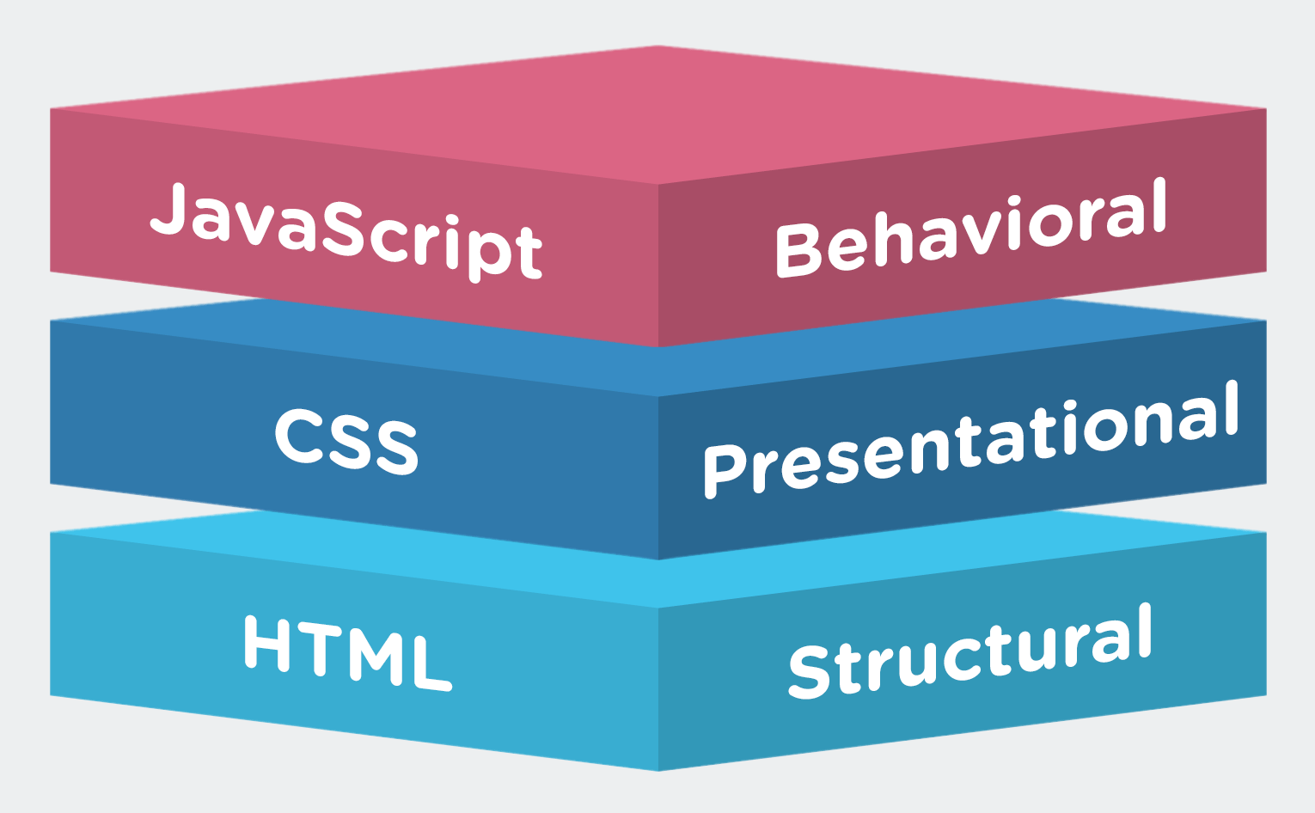

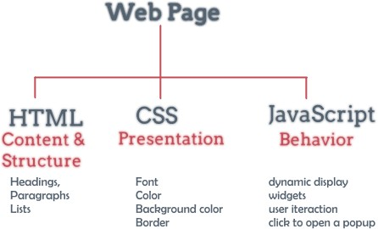

# Strengths

1. The main strength of our project is that it has a very simple and user-friendly user interface (UI) followed by awesome looks upon each click.
2. It has more than 10 webpages which together makes the website. Thus one can easily fly in and out without hanging on a single page.
3. It has got External CSS file for each webpages which makes it more reliable to edit.
4. All the links preserved at a place to keep fast navigation throughout the website. No loadings, no buffering, no lagging just smooth navigation.

# Weaknesses

1. Although it is not concerned with any kind of major defects/failure but as we are revolving on a technological platform there may be few chances of flaws like missing of a file, deletion of any CSS file leading to affect the whole webpage, etc.
2. Since, in our project the major part is database oriented which we have not given the connection for going through.
3. It is a static website and effect of all changes can be seen clearly.
4. Due to the limitation of our knowledge we were unable to integrate it into a fully functional website.

# Future Scope

It is a blueprint where all necessary question are answered and problems are solved as well as the plan of action is well built. It is made with a lot of planning in order to function as needed, reach the right people, and accomplish all social goals. But with the limitation of knowledge, it is hard to implement it with full force. So, we can implement modern methods of designing and scripting.

All information is documented for easy reference to keep everyone headed in the same direction as of the website. With good record of scope, time and effort can be saved and communication problems are minimized enabling designers to build more effective and dynamic website.